Debugging ISAPI applications with WWSDebug

WWSDebug is a special edition Zero Configuration version of WinShock Web Server designed to enable developers to quickly run and test Web applications destined for deployment on ISAPI compatible web servers such as Microsoft IIS, Apache, Omni HTTPD, or WinShock Web Server.

WinShock Web Server is a commercial grade Web server written in Borland Delphi and available from Brain Patchwork (http://www.bpdx.com). WWSDebug is a special edition built in Borland C++Builder.

To debug your ISAPI application using WWSDebug, you need to create an ISAPI web application DLL, and configure Delphi to use WWSDebug.

See the topic “Deploying EWF ISAPI applications” for details on how to create an ISAPI application.

Unloading your ISAPI application

If you have previously deployed it to a local web server such as Microsoft IIS, you will want to make sure that you unload it. In Microsoft IIS you simply need to select the properties of the virtual directory and check the unload button.

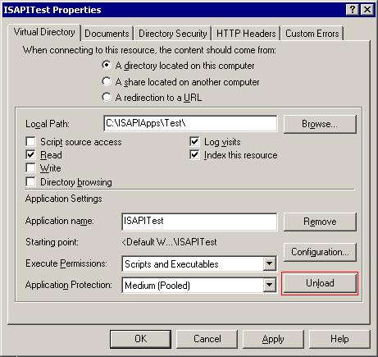

If that button is not grayed out then your web server has loaded your application, and you will need to click the button to tell it to release your DLL.

Configuring Delphi to use WWSDebug

To debug your DLL you must select “Run|Parameters…” from the Delphi menu and give Delphi a host application that will run your DLL, this will be WWSDebug.EXE.

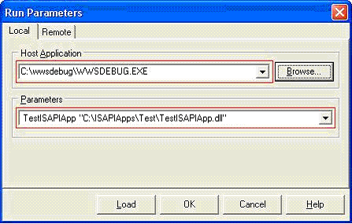

Now the only thing left is to give WWSDebug parameters that will tell it the alias that your application will be hosted on and a path to find your DLL.

In this case we will use TestISAPIApp as the alias, but it could really be any meaningful name.

The second parameter is the path to your ISAPI application. If you are using a path with space characters suche as “C:\My Documents\ISAPI\” make sure you add double quotes around it otherwise WWSDebug will only extract only the first part of the path and will give you the following error when it can’t find the ISAPI DLL.

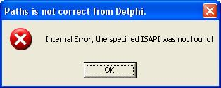.

Assuming you have everything set up properly, you can now simply hit F9 – Run and WWSDebug will execute, creating a virtual path with the same name as your applications main form that you passed, load your ISAPI Web Application DLL, and then tell your browser to navigate to the main page being served by the full web server inside WWSDebug. You can set break points and debug and run just like you would any other Delphi windows application.

When you are finished you will find the WWSDebug splash screen under your browser window.



Clicking on “Stop Debugger” or selecting “Run|Program reset” in Delphi will stop WWSDebug.

Configuring WWSDebug for additional paths

When you run WWSDebug it will create a virtual path for you to wherever your dll is. However you may want to add additional paths to WWSDebug for example creating an Images path. To do this you can use WWSDebugVirtPathEditor which is a simple ExpressQuantumGrid 4 application that will allow you to edit the virtual paths configuration file for WWSDEBUG.

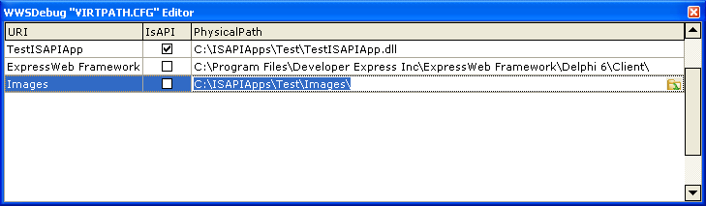

In this case we have created a virtual path called Images that will point to a subdirectory called Images of our test directory.

You can delete a row by hitting the delete key while holding down the Control key, you can insert a row by moving to the last row and hitting the down arrow.

Note the VirtPath file is never cleared out, so as you debug more and more ISAPI applications you will find that this list will continue to grow so it makes sense to use the Virtual path editor every now and then to trim it down to the paths you are actively working with.
WWSDebug logs

WWSDebug contains some of the logging facilities of it’s bigger brother WinShock Web Server. There are 3 log files created when you access the WWSDebug server,

The first is the Apache style log that is named with the file name of the 8 digit date and the extension .log (eg: 11012002.log) this tells you which pages were requested and by which user agent (browser) and the result of that request..

example:
127.0.0.1 - - [01/Nov/2002:00:33:19 -0480] "/cxwebpagemodule2" 302 0 "-" "Mozilla/4.0 (compatible; MSIE 6.0; Windows NT 5.1; Q312461; .NET CLR 1.0.3705)"

The Second log file is the Referers log which tells you which pages pointed the user to your site.

example:
[10/24/2002 9:16:30 PM] http://127.0.0.1:3322/ -> cxwebpagemodule2/

The final log is the Browsers log which provides a list of all the user agents (Browsers)_ that accessed your server.

example:
[10/24/2002 9:16:26 PM] Mozilla/4.0 (compatible; MSIE 6.0; Windows NT 5.1; Q312461; .NET CLR 1.0.3705)

These logs, particularly the Apache log can provide a useful debugging aid.

